Soaring Eagle Scholarship
Joseph & Lydia Brophy Memorial Scholarships
Robert & Carole Edland Memorial Scholarships
Bradford Stanley Frohmader Scholarship
Margaret Grelle Memorial Science Scholarship
Herbert & Barbara Heili Scholarship
Msgr. Delbert Malin Scholarships
Patrick J. & Patricia M. Murphy Family Scholarship
Bishop John Paul Scholarships
Russell & Dawn Pierce Scholarship
Quillin Family Scholarship
Raymond/Coleman Scholarship
Sharon Ballard & George Kerckhove Scholarships
Elizabeth & Karlton Keppel Memorial Scholarship
David L. Wadzinski Memorial Scholarship
Leroy & Patricia (Platz) Wannemuehler Memorial Scholarship
Eugene & Mary Ann Roesler Art Scholarships
George & Virginia Schneider Scholarships
Ernest B. Tremmel Scholarships
Dr. A.W. Hickey Scholarships
Cecil Allen Family Scholarship
Joseph W. Wewerka Memorial Scholarships
Cole Berra Memorial Scholarships
Howard Birnbaum Sr. Memorial Scholarship
Kay Berra Scholarship
Henry C. Eden Scholarship
Aquinas Golf Outing Scholarships
Peter J. Murray Scholarship
Eugene Murphy Scholarships
Kathy Forslund Scholarships
William P., Doris J., & Timothy R. Skemp Memorial Scholarship
Dineen Family Children & Memorial Scholarship
Fr. Robert Hansen Scholarship
James L. Kiffe Scholarships
Vernon F. Dale Scholarships
Stoll Family Scholarships
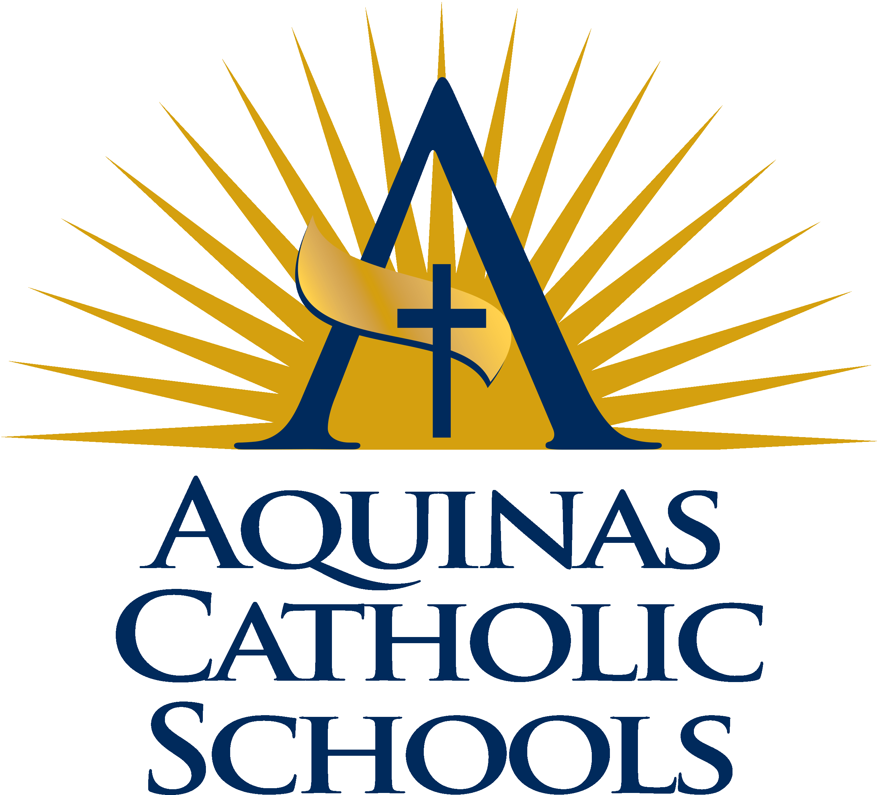
Mardi Gras Scholarships
Snapp Family Scholarships
Francis E. Zahn Scholarship
Venner Scholarship
Darby Whalen Scholarship
Fred & Mary Funk Scholarship
William Rudolph Scholarship
Don & Geri Houlihan Scholarships
Dr. Charles J. Mears Memorial Scholarships
Don Gallagher Family Scholarship
John & Helen Pavela Memorial Scholarship
Father John Pinion Scholarships
George & Margaret Ellenz Scholarships
John Elliot Foundation Scholarships
Julie Wagner ‘It Takes A Village’ Scholarships
Sister Lucille Kleinheinz Memorial Scholarship
Norman & Susan Flynn Scholarship
Bishop John Paul Estate Scholarships
Two Eagles Foundation Scholarships
IMPACT Service Scholarships
Rod Sutherland Memorial Scholarship
Graduation Scholarships
Will Reckase Memorial Scholarship
M & M Memorial Scholarship
Charles J. Mathy Jr. Scholarships
George P. & Evelyn Miller Scholarship
Coach Nockels Memorial Scholarship
Marian Pavela Pro-Life Nursing Scholarship
Class of 1976 Scholarship
A.J. Petras Memorial Scholarship
Edward & Ella Poehling Scholarship
Luminary Scholarship
Teddy (Fregin) Von Arx Memorial Scholarship

