Aquinas B & K Scholarships
John Bissen Memorial Scholarships
James Maney Estate Scholarships
Michael Kenneth Pitz Memorial Scholarships
Team Brown Forward Scholarship
Mike & Bethany Bakalars Scholarship
Matt & Megan Bisnfeld Forward Scholarship
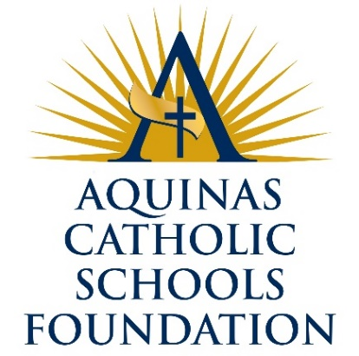
Forward Empowerment Scholarships
Ray & Kay Eckstein Foundation Forward Scholarship
Fowler Family Forward Scholarship
Anita Froegel Forward Scholarship
Gagermeier Family Forward Scholarship
Mark & Debbie Hansen Scholarships
Houser Family Forward Scholarships
Kerrigan Forward Scholarship
Marty Kirchner Forward Scholarship
Amy Beth Klein Memorial Scholarship
Mathy Forward Empowerment Scholarships
McGarty Family Forward Scholarships
Donald & Louise Schams
Dr. Gerald & Marie Miller Forward Scholarship
Miskowski Family Forward Scholarship
Dr. James & Barbara Murphy Scholarship
Pretasky Family Forward Scholarship
Mark & Peg Schneider Forward Scholarship
Robert & Frances Skemp Family Scholarships
Barbara & Phil Quillin Forward Scholarship
Elizabeth & Samuel Solverson Forward Scholarship
James & Elaine Schauls Pathway to Successful Future Scholarship
Quillin Family Forward Scholarship
Cory & Jennifer Roupe Scholarship
Stilp Family Forward Scholarship
River Bank Forward Scholarship
Legacy Scholarships
Ondell Forward Scholarship
Kirchner Family Scholarship
Graduation Scholarships
Donald & Louise Schams Post Grad Scholarships

